Letter Template – Export Medical Record

To support printing a client’s medical record directly from Profile EMR without saving the file to your computer, a new letter template has been created. This replaces the previous Export Medical Record (With Details) workflow.
Steps to Use the Letter Template
- Open a new Encounter for the client.
- Enter DRR\ to launch the Documentation Released from Record list form
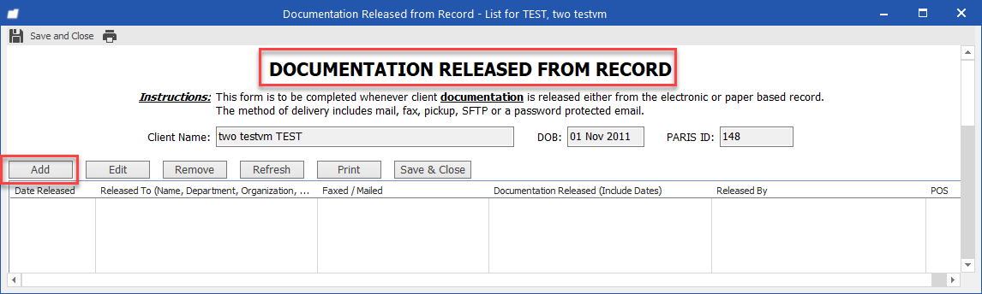
- Clicking on ADD will open the blow window. Complete the fields as indicated in the screenshot and click OK
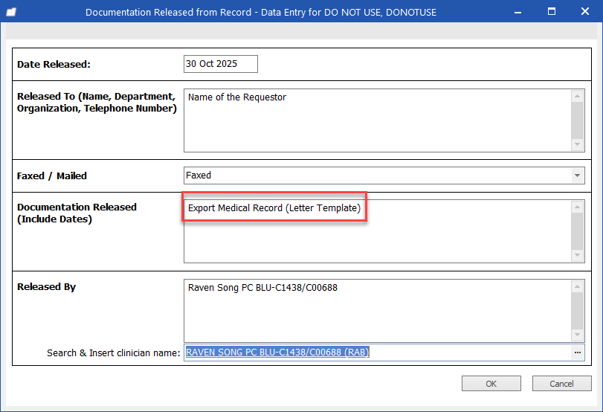
- Click Save & Close button close the form
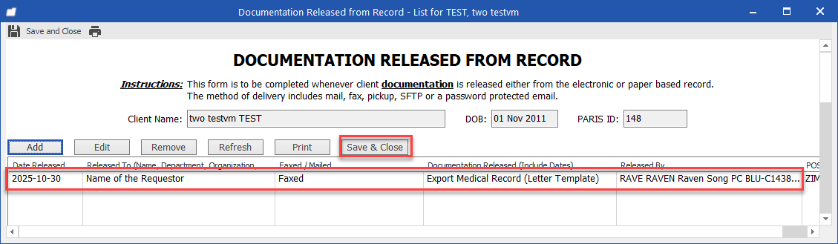
Note: The contact title is changed to Documentation Released from Record
- Navigate to the Actions menu and select Letter module.
- In the Look for field, type “Export Medical Record” and double-click the template from the search results.
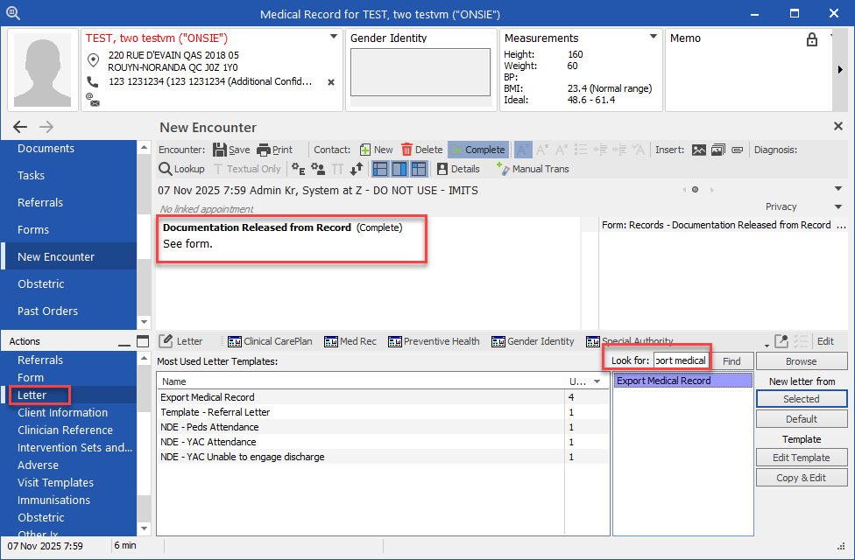
- A warning message will appear.
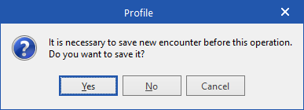
  - Click Yes to continue.
- A new letter will be created containing the following information:
  - Clinic letterhead
  - Client details (demographics)
  - Problem List (Diagnosis, Adverse/Allergies, Procedures, Social/Risk, Administrative and Pregnancy)
  - Usual Medications
  - Overdue Tasks
  - Interventions Still Due
  - History (Family, Social, Past and Obstetric)
  - Immunizations
  - Encounters (for the logged-in POS only)
- To include additional information, go to the Attachments tab and select from the following options as needed:
  - Documents
  - Letters
  - Pathology / Lab Results
  - Radiology
  - Referrals
- Attachments Tab Each category in the Attachments tab initially displays only the 20 most recent items. To view additional items:
  - Select the desired category
  - Click Load More to display further items
  - Repeat as needed until all items are visible
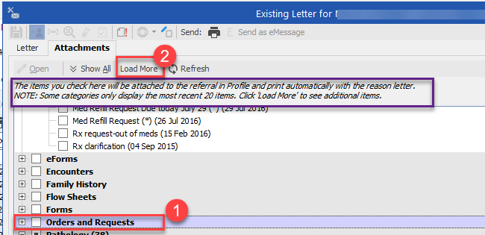

Note: Do not select Adverse, Diagnosis, Encounters, Social/Risk, or Usual Medications as these are already included in the main letter body.
- Print the letter:
  - Choose your printer or PDF.
  - If saving as a PDF, always save to your network drive (H:), not your desktop.
- (Optional) To preview the letter before printing, click the Preview icon.
