Panorama Integration
Here is an overall illustration on how data moves from EMR to Panorama.
Panorama wants to collect patient information on people with the following diseases:
- Chlamydia
- Gonorrhea
- Syphilis
- LGV (Lymphogranuloma venereum)
So anytime the CPS form is updated and they have any one of these diseases, an update will be sent to Panorama. This is sent in the form of a FHIR message via Iguana. (To be discussed below).
There is specific data that is collected when they meet the above criteria. All of these are stored in HRIs. This is data like: demographics (full name, address, DOB, etc), medications (type of medication, dosage, route, etc), and many more. There are around 120 pieces of information that get sent to panorama. All this data is also collected and sent on a nightly basis, this will be done via EMRs scheduled task.
There are several components involved in the process of getting the data from the CPS form and transforming it into a json FHIR message, the message type accepted by Panorama. These components are:
- CPS – STI Management Form – the form where STI clinic users enter information
- PANORAMA_EXEC macro – this macro has 2 parts to it
  - Run Find Objects query that returns list of patients that meet the criteria
    - This CSV file has columns containing the information required by Panorama
  - Creates a FHIR message that is dropped into a folder on the EMR applications server (SPAPPEMR003). This folder is monitored by Iguana, when it detects a json file in the folder, it picks it up and sends it to Panorama
- Iguana – the interface engine we use to send messages to Panorama
Each of these components will be discussed in detail.

CPS – STI Management Form
This is the data entry form used by the clinicians at the STI Clinic. You’ll notice when viewing the form in design view that there are numerous hidden fields, these fields is data being collected and sent to Panorama. One thing to note about most of the data being sent to Panorama is that they need to be sent as concept codes. For instance, when the disease Chlamydia is being sent to Panorama, the text is not being sent but, in fact, its concept code 240589008. Concept codes extend to almost all clinical information.

PANORAMA_EXEC macro
This macro is scheduled to run nightly by the EMR scheduled tasks. It will be enabled at go-live.
There are 2 main parts to this macro:
- Creating the extract (Find objects query). This will create a file called “EMR_Patient_Results.txt” on the application server. This essentially is a result set of the query in the form of text file. The find objects query (called FINAL - Panorama Extract) returns all relevant Panorama data of the patient WHERE the CPS form has a modified date of “today” and where the diseases include: Chlamydia or Gonorrhea or LGV or Syphilis. This CSV txt file will contain approximately 121 columns of data.
- Generating the FHIR messages. 2nd part of the macro will open that “EMR_Patient_Results.txt” and generate a FHIR message in the form of a json file and drop it in a specific folder on the application server. There is a specific format that the FHIR message must adhere to, this is accomplished using a template. Within the template, placeholders exists where a simple search/replace function is executed to populate the placeholders with values from specific columns in the extract. Then finally saves it as a json file. The template file is called “Panorama FHIR template.txt”
When looking closely at the “EMR_Patient_Results.txt” file (open in excel), you’ll see the full collection of information requested by Panorama. You’ll notice that some data is recognizable (ie. First name, last name, etc) but also concept codes as mentioned earlier.
In addition, you’ll notice character separated values, these reflect the different properties associated with that value. For example, a medication has several properties: date of treatment, drug code, provider, dosage, route, frequency, duration, etc. And within these values, you may see further character separated values. An example is when a patient has multiple medications, it would look something like:
This patient has 2 medications separated by a pipe (“|”) and each medication has properties that are separated by a colon (“:”). Notice that the values are translated to concept codes. (This is the Medications List column in the extract)
20190207:190::Henry Boy:100:INV.UnitOfMeasure1:ORAL:2X:7:DAYS:20190207:20190207:N:|20190207:168::Henry Boy:1:GRAM:ORAL:1XO:1:DAYS:20190207:20190207:N:

IGUANA
Iguana is the interface engine used to send the FHIR messages from EMR to Panorama. On the application server (SPAPPEMR003), these are the relevant folders:
D:\PANORAMA
- As mentioned above, the first part of the PANORAMA_EXEC macro will generate an extract of patients that meet the disease criteria. The file “EMR_Patient_Results.txt” will drop into this folder.
D:\PANORAMA\FHIR Messages
- The second part of the PANORAMA_EXEC macro generates the json FHIR messages and drops them in this folder.
D:\PANORAMA\Log
- This folder will contain a history of the daily extracts. The files are named “EMR_Patient_Results” with the date/time appended to it. For example, EMR_Patient_Results_20190110164434.txt. This is useful for troubleshooting and in the case where FHIR messages need to be re-generated for a particular day.

TROUBLE-SHOOTING
Manually Generating FHIR messages locally
Typically all errors are related to the data in the extract.
To aid in troubleshooting, 2 macros have been created and accessible in REP. These 2 macros essentially make up the PANOARAMA_EXEC macro but are broken up separately to help in troubleshooting.
They are:
- PANORAMA_RPT
- PANORAMA_TBS
PANORAMA_RPT generates the EMR_Patient_Results.txt batch file to your local H:\<root>. This will include a list of all the patients returned from the Find Objects query. If you want patients to meet a certain condition, you will need to modify the FO query (FINAL – Panorama). The default condition is to return all patients with CPS forms with a modified date of “Today”.
PANORAMA_TBS generates the json FHIR messages based on the EMR_Patient_Results.txt file found on your local H:\<root> folder. Ensure that you create a folder H:\fhirmessages as this is where the messages will be created.
Error in Scheduled Task
When the scheduled task fails to complete, this usually points to an execution error in the PANORAMA_EXEC transformation macro. Under System Tasks Explorer, you will find the error under the “Last Run Result” column.
This macro as previously mentioned is responsible for generating the extract file and then the json FHIR messages, an error usually indicates that it failed to generate a message for one of the records in the extract file (EMR_Patient_Results.txt). To determine which record in the extract is the culprit, we attempt to re-generate the messages. We can do this in the REP environment.
Here are the steps:
- First retrieve the EMR_Patient_Results.txt from the PROD application server (SPAPPEMR003) under the d:\Panorama\ folder. The EMR_Patient_Results.txt is the most recently generated batch file (the previous evening). If you look under d:\Panorama\log folder, you’ll see a history of the batch files, this will allow you to re-generate messages from previous days. Copy the file to your local H:\<drive>
- Open and run the PANORAMA_TBS macro (previously mentioned). You’ll notice the FHIR messages being created. Line up the records in the batch file with the FHIR messages to determine at which record, it failed to create the message.
- Same error from the scheduled task should appear indicating the line number. At this point, you should be able to determine the problem. Ensure to fix the issue in both PANORAMA_EXEC and PANORAMA_TBS.

Error in Iguana
When discovering an error(s) under the ERRORS column of the Iguana Administration launchpad.
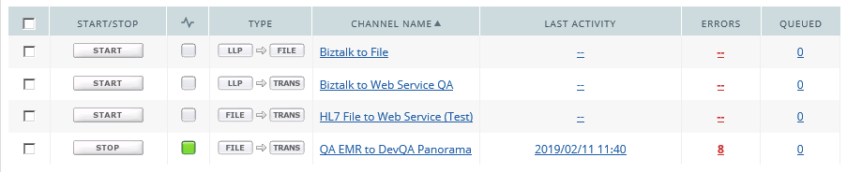
Click on the number under Errors and it will provide you with a log such as below:
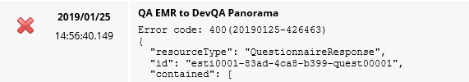
This will provide you with the FHIR message that failed to be sent to Panorama. Copy the text starting from the line below the Error code starting at “{“. And paste it in a json validation tool, it will help you determine where in the message causes the error.

